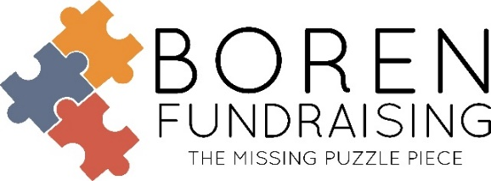
New Program Change!
COUNTRY MEATS
50% PROFIT
SMOKED SNACK STICKS
Due to all the nationwide price increases, Country Meats is raising their prices while continuing to keep the same great quality they have always had!
- Same weight at 1 oz. Sticks.
- Choose up to 6 flavors per case (each bag can be a flavor). Choose from 12 plus flavors.
- There are 144 sticks per case (6 bags of 24 sticks), PLUS 10 FREE STICKS!
- Minimum Order 1 Case. (Canisters and posters are available at no charge.)
NEW PRICES!
- Case cost - $108 plus $10 for shipping and handling.
- 75¢ cost per stick.
- Sell at $1.50 each or we suggest you sell them as 2 for $3!
MORE PROFIT!
- Selling each stick at $1.50 each = 50% PROFIT!
- $108 profit per case you sell!
- Sell the extra 10 Free Sticks ($15 Retail) earns you another $5 Profit = $113 in Profit per case!
HOW TO ORDER! (3 choices)
- Email your order to office@borenfundraising.com (OR)
- Text your order to 918-688-2675 (office). Please include your contact information (OR)
- Call your order to 918-688-2675 (office).
- 30-day billing if the invoice is being paid by a school check. Otherwise, credit cards are accepted.
- As an established customer, you can order directly from Country Meats with your email and password.
GREAT IN-SCHOOL FUNDRAISER! (Nutritional information can be found on our website below or by emailing office.)
- Muskogee Band – 22,176 Sticks
- Grandview Band – 18,000 Sticks
- Cedar Heights Elementary – 15,840 Sticks
- Moore High School Band – 8,784 Sticks

The average group selling Country meats will sell 7 cases. With this new program you will earn $791 profit on those 7 cases. Last year the profit on 7 cases was $455. That’s an extra $336 profit for your group!
Like us on Facebook, Boren Fundraising – www.borenfundraising.com
Soni Brown ● Office Manager ●918-688-2675 ● office@borenfundraising.com
Dwain Boren ● 918-688-7725 (text only) ● dwain@borenfundraising.com
Family Owned and Operated Since 1972

