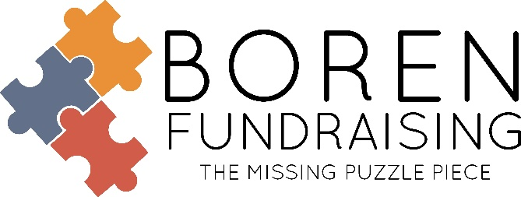

SLOW SMOKED SNACKS, FARMERS MARKET & POPPIN POPCORN RESULTS!

School # of Sellers % of Participation # of Items sold Retail
Collinsville HS Band 84 35% 845 $14,519
Grove Upper Elementary 97 17% 884 $13,812
Eufaula MS/HS Band 92 42% 1017 $12,424
Oologah MS/HS Band 53 35% 709 $11,515
Bixby Middle School Choir 55 52% 680 $7,850

- 40% Profit
- Pre-Packed by Student
- Prizes Provided-See Parent Letter
- No Returns
- We Provide the Following for your Fundraising Sale:
Samples for kick-off, Brochures and Order Forms, Parent Letters, Sales Report by Student, Pre-Packed by Student
- School PO to Boren Fundraising: Net 15 Days. If invoice is paid within 15 days after receipt of product you may deduct the freight charge. All other accounts: payment is due on delivery of product.
We recommend Slow Smoked Snacks – sales will be higher – since items are sold at $16

IN HAND BROCHURE

Like us on Facebook, Boren Fundraising – www.borenfundraising.com

Soni Brown ● Office Manager ●918-688-2675 ● office@borenfundraising.com
Dwain Boren ● 918-688-7725 (text only) ● dwain@borenfundraising.com
Family Owned and Operated Since 1972

