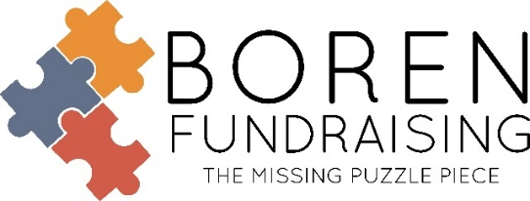
Neighbors Cookie Dough Program
Our #1 Producing Program
America’s Favorite Treats Brochure
(Women Owned) (USA Made Products)

40% Profit:
Boren Fundraising will provide prize program
We Provide:
- Brochure, Order Form, and Parent Letters
- Data Sheet of Total Student Sales (to figure prizes)
- Pre-Pack of Student Orders
- Freight Paid on 250 Items or More
- 30 Day Billing with School Purchase Order Provided to Neighbors Cookies
What You Do:
- Video Kickoff
- Make copies of all student order forms and mail student order forms to Boren Fundraising
- Allow 3-4 weeks for delivery after Boren Fundraising receives the order forms
- Check the orders when handing out the product
Under 250 total items will incur a $170 minimum surcharge
(Total Items includes online sales with ship to school plus brochure sale items.)
Minimum Order is 100 total items
Less than 10% participation will incur additional charges

Results
School # of Sellers % of Participation # of Items sold Retail
Bixby Central Elementary 500 46% 4927 $87,002
Preston Elementary 212 49% 2959 $51,915
Hall-Halsell Elementary School 141 44% 1763 $33,189
Heritage Elementary 205 38% 1652 $29,292
Bixby North Intermediate 181 33% 1586 $28,111

IN HAND BROCHURE PLUS ONLINE ORDERING WITH SHIP TO SCHOOL AND SHIP TO HOME OPTIONS AVAILABLE!!!
Like us on Facebook, Boren Fundraising – www.borenfundraising.com
Soni Brown ● Office Manager ●918-688-2675 ● office@borenfundraising.com
Dwain Boren ● 918-688-7725 (text only) ● dwain@borenfundraising.com
Family Owned and Operated Since 1972

