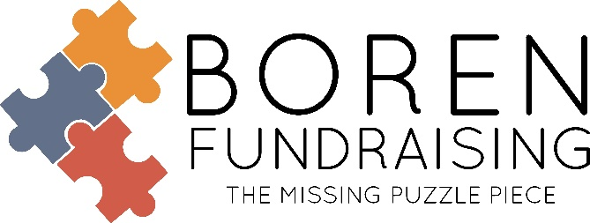
MERAKI JEWELRY FUNDRAISER

- 50% Profit
- $16 retail/$8 profit
- Pre-Packed by Student
- Prizes – for every 10 sold you will receive one for FREE
- No Returns
- We Provide the Following for your Fundraising Sale:
Brochures, Order Forms, Collection Envelope, Parent Letter, Pre-Packed by Student
- School PO to Boren Fundraising: Net 30 days.

RESULTS
School # of Sellers % of Participation # of Items sold Retail
Bixby North Intermediate 44 9% 261 $4,176
Childers MS Vocal 15 10% 87 $1,392
Stilwell FCCLA 18 38% 60 $960

IN HAND BROCHURE

Like us on Facebook, Boren Fundraising – www.borenfundraising.com
Soni Brown ● Office Manager ●918-688-2675 ● office@borenfundraising.com
Dwain Boren ● 918-688-7725 (text only) ● dwain@borenfundraising.com
Family Owned and Operated Since 1972

