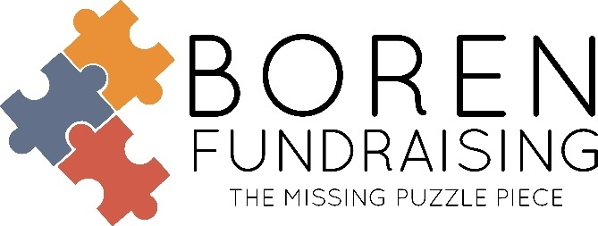
BOREN CHEESECAKE RESULTS!
DUE TO QUALITY OF CHEESECAKES
School # of Sellers % of Participation # of Items sold Retail
Oneta Ridge MS Vocal 71 57% 715 $16,445
Ft. Gibson 80 42% 625 $13,991
Muskogee Band 50 33% 447 $10,281
Woodward Band 72 33% 520 $11,960
Pryor High School 53 46% 471 $11,040
Keys School Band 58 53% 600 $13,800
Centennial MS Vocal 47 41% 425 $9,965
Skiatook MS Band 65 39% 404 $9,292
Union Boys/Girls Soccer 41 34% 349 $8,027
Sequoyah MS-BA Vocal 69 48% 385 $8.736
Grove HS Band 55 48% 386 $8,614
Cushing MS/HS Vocal 38 48% 270 $6,210
- NO CORN SYRUP - ALL NATURAL – NO ARTIFICAL ADDITIVES
- SECOND GENERATION – FAMILY BAKERY
- RECEIVING HIGHER PARTICIPATION %
- HIGHER SALES = HIGHER PROFIT $$$
- YEAR AFTER YEAR REPEAT SALES
Like us on Facebook, Boren Fundraising – www.borenfundraising.com

Soni Brown ● Office Manager ●918-688-2675 ● office@borenfundraising.com
Dwain Boren ● 918-688-7725 (text only) ● dwain@borenfundraising.com
Family Owned and Operated Since 1972

